- An absence of revisions to the ONS' UK GDP growth estimates in Q4's national accounts left the story of an economy mired in stagnation last year unchanged. But a decent rise in real household incomes in Q4 revealed one of the benefits of falling inflation. And a still-elevated household savings ratio suggests more scope for consumers to support spending by saving less.
- There was little to report from economic data this week, bar an improvement in the CBI retail survey. Meanwhile, comments from the two most hawkish members of the Monetary Policy Committee suggest they're still a long way from supporting a cut in interest rates.
The extent to which Q4's national accounts would revise estimates of a weak economic performance at the end of last year was the key uncertainty in advance of the ONS' publication. In the event, there was no change to the previous estimate that GDP shrunk 0.3% in Q4. Growth, or a lack of it, in earlier quarters was also left unrevised, meaning the economy is still estimated to have expanded by only 0.1% in 2023. Excluding 2020, when Covid hit, this was the weakest rise since the global financial crisis in 2009.
There was also little to report in terms of changes to the expenditure components of GDP. Consumer spending, investment and net trade all dragged on output in Q4, offset partly by a rise in government consumption.
Some of the fruits of lower inflation and still-strong wage growth were evident in the income breakdown for Q4. Real household incomes rose 0.7% in Q4, up from zero growth in the previous three months (revised from +0.4% previously). Relatedly, households' balance sheets continued to strengthen in the final quarter of last year. Household debt fell to 123.7% of incomes, the lowest since Q2 2003. And the household saving ratio ticked up to a 10-quarter high of 10.2% from 10.1% in Q3 (Chart 1).
Q4's rise in incomes and households' unusually healthy financial position gives us more confidence that last year's contraction in GDP will have proved short-lived and that a combination of fast-falling inflation and actual and prospective cuts in taxes and interest rates will trigger a consumer-led recovery this year.
Chart 1: Q4 saw households' debt burden drop and the saving ratio rise further
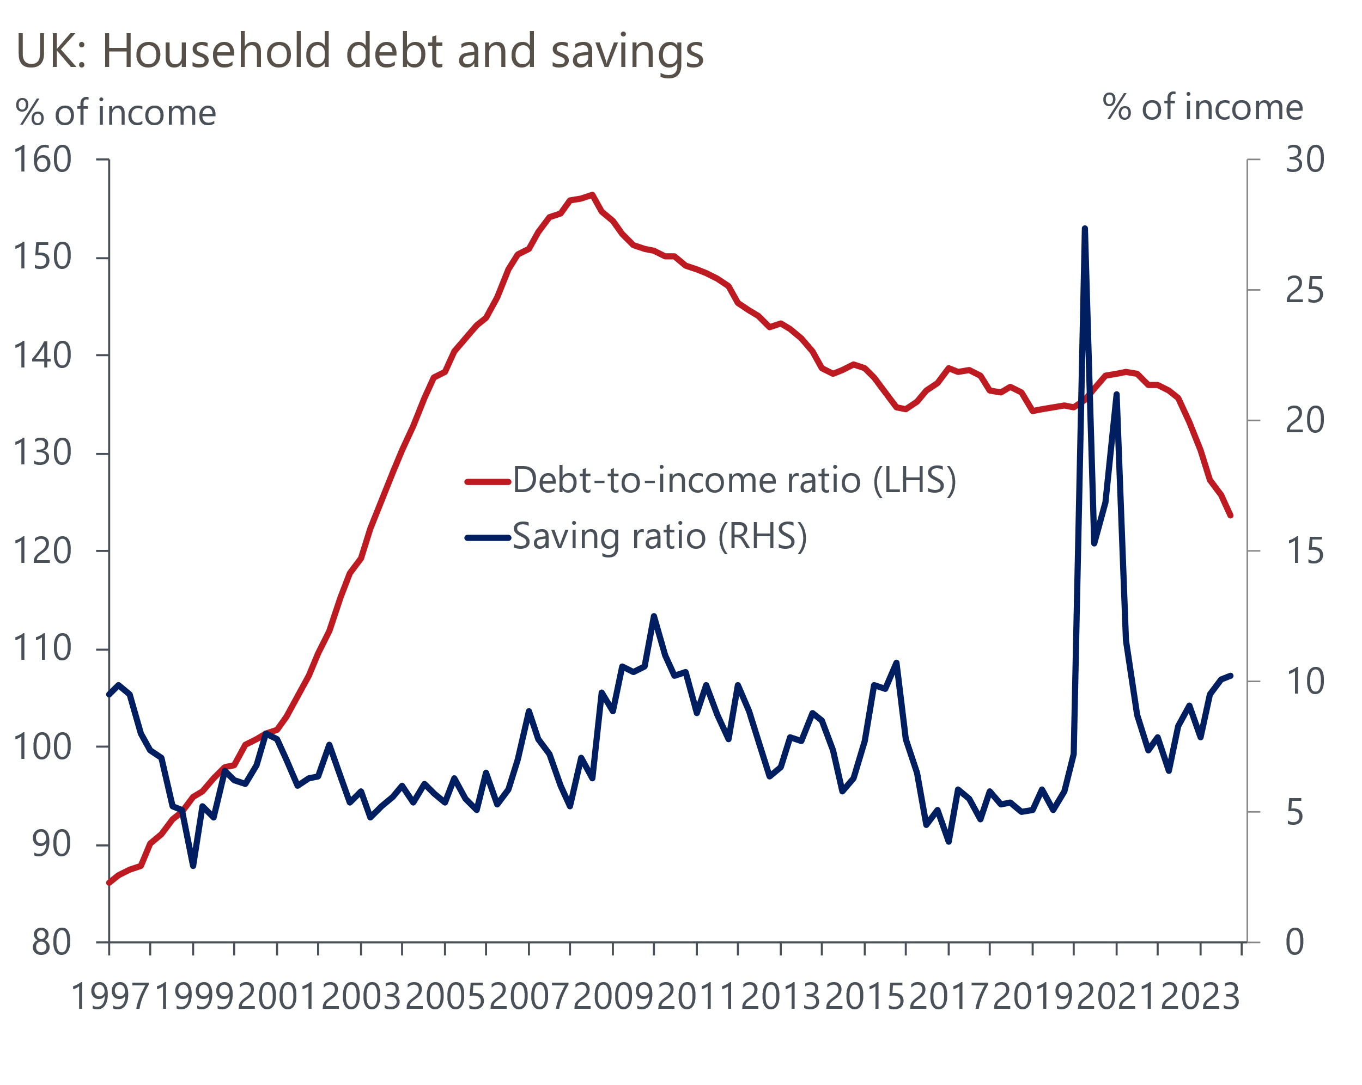
Source: Oxford Economics/Haver Analytics

There wasn't much in the way of economic data this week to support or disprove this expectation. But an improvement in the CBI's retail survey for March was consistent with other recent evidence of a retail revival. That the survey's headline balance showed sales broadly flat on a year earlier was nothing to shout about in isolation. But this was the first month since April 2023 not to see a decline and is consistent with the official measure of retail sales holding onto recent gains (Chart 2).
Chart 2: The latest CBI retail survey showed sales stabilising for the first time in 10 months
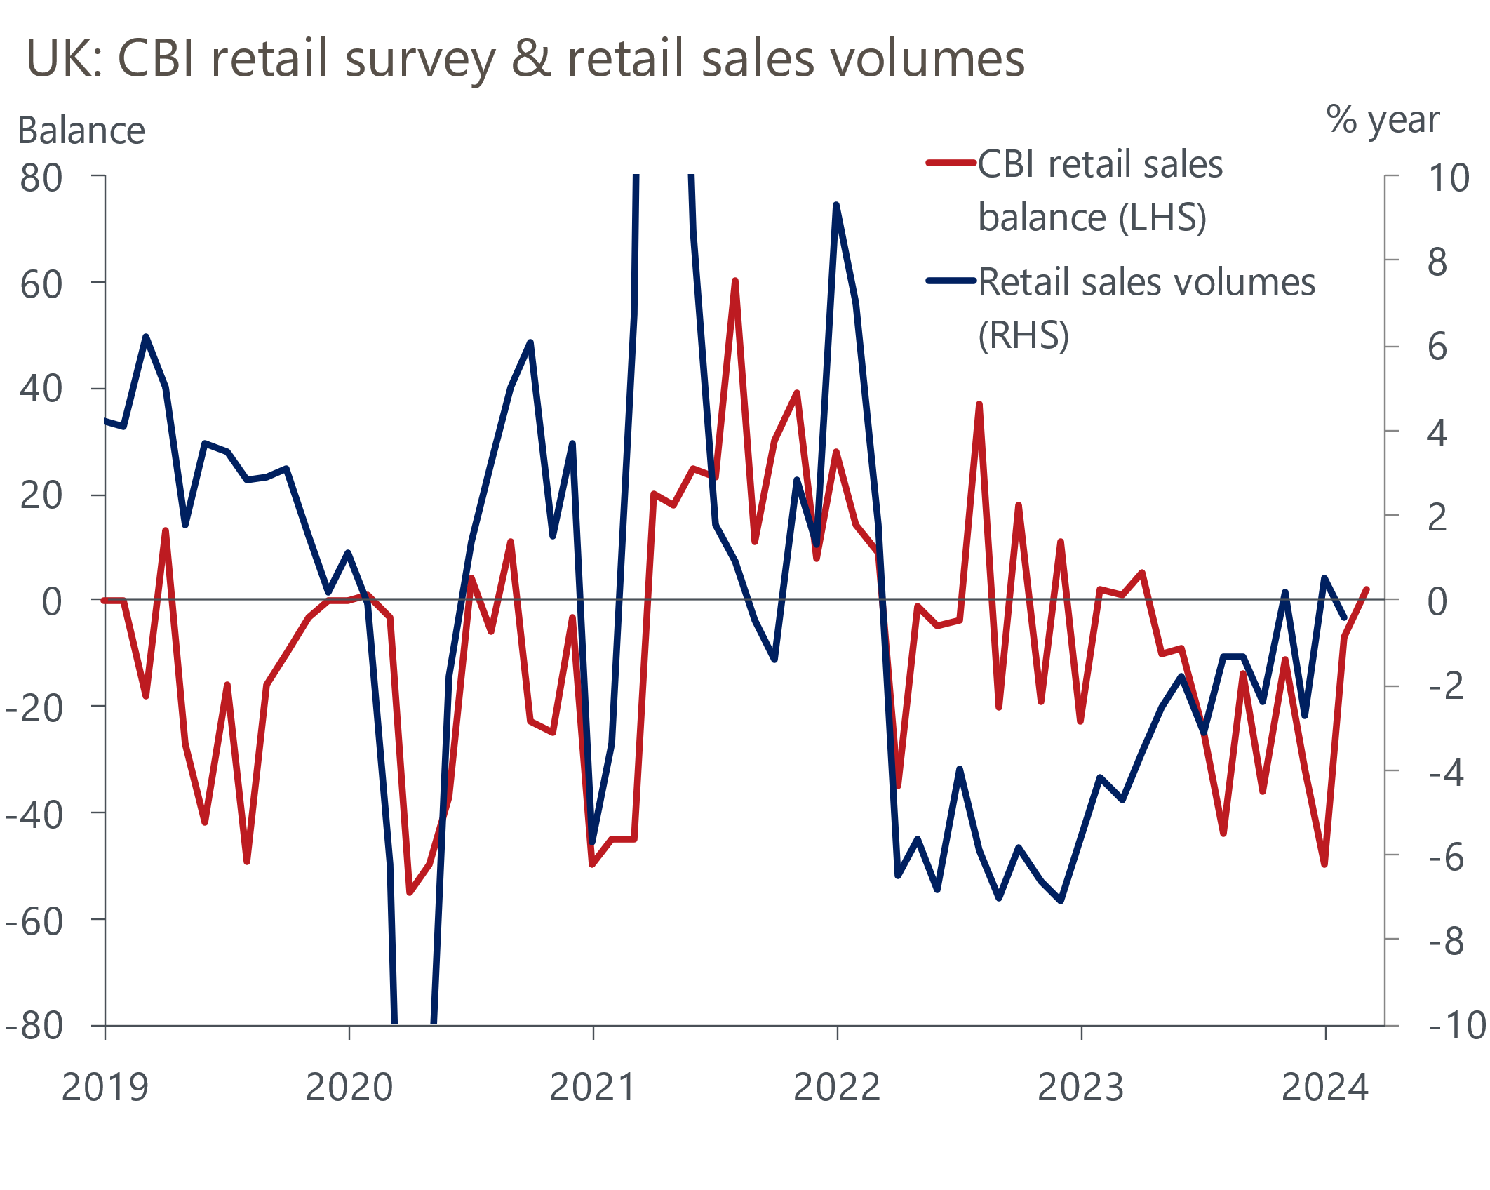
Source: Oxford Economics/Haver Analytics
Meanwhile, Catherine Mann and Jonathan Haskel, both external members of the Monetary Policy Committee and with a track record of hawkishness on interest rate decisions, made public comments this week. The two members had reined back their hawkishness in March's MPC meeting, switching from previously voting for rate hikes to falling in line with majority support for no change. But their latest comments suggest a further move in favour of cutting Bank Rate may take some time. In Mann's view, inflationary pressures from wages and services prices meant current market expectations of three 25bps cuts in Bank Rate this year were "too many" and the same factors meant it was unlikely that the BoE would move before the US Federal Reserve.
Haskel was more explicit in ruling out his support for a rate cut for the foreseeable future. The external member said that undershoots in inflation relative to the BoE's forecast, and signs that the mismatch between job vacancies and available workers was easing, had contributed to his vote change earlier this month. But in Haskel's view, "although the fall in headline inflation is very good news, it is not informative about what we really care about: what we really care about is the persistent and the underlying inflation,”. Consequently, “I think cuts are a long way off.”
Bar March's meeting, both Mann and Haskel have been out of sync with the majority on the MPC for some time. We therefore wouldn't place much weight on their views as a guide to the future path of interest rates. We continue to think that developments in underlying inflation and pay growth should give the green light to cuts in Bank Rate beginning in June.
Finally, this week delivered an update on the other half of the BoE's activities – preserving financial stability – with the publication of the Financial Policy Committee's latest quarterly update. The FPC acknowledged that households continued to face pressures from the increased cost of living and higher interest rates.
But the committee now expects a smaller increase in the share of households spending a high proportion of their income on mortgage payments over the next two years than three months past. And although mortgage arrears had increased modestly in the last few months, strong wage growth and low unemployment had contained the rise and arrears remained low by historical standards. So while financial stresses facing households haven't gone away, the outlook is looking more promising than of late.

The week ahead
A truncated week for data releases following Monday's Bank Holiday will give some insight into house prices, lending to the private sector and the latest state of activity in the economy's major sectors.
On the latter, we expect March's manufacturing and services PMIs to mimic the broadly upbeat story told by the month's earlier flash readings. Although the flash services PMI dipped slightly, it remained in plus-50 expansionary territory for the fifth successive month. And the flash manufacturing output index rose above the 50-mark for the first time since February 2023. With no obvious developments in late March to meaningfully shift the dial on the flash numbers, we expect final services and manufacturing PMIs of 53.5 and 50.3 respectively.
We think February's data on lending to households will show the recovery in mortgage demand which began in late 2023 continued that month. Quoted mortgage rates have come down since last summer and the mood-music around the housing market has improved as the economic outlook has become less unpredictable and house prices have proved more resilient than expected. We forecast mortgage approvals to have picked up to 56,000 in February. Net mortgage lending remained surprisingly weak in January, falling £1.1bn. This was despite the rise in approvals in previous months. But we expect the lagged effect of previous rises in approvals to have pushed net lending into positive territory in February.
Net unsecured lending rose to £1.9bn in January from December's £1.3bn. But this was entirely a function of a fall in repayments, with gross lending falling slightly compared with December. Under the assumption that repayments returned to more normal levels in February, net consumer credit is forecast to have fallen to £1.4bn.
Table 1: Week ahead calendar
Date | Events | Period | Measure | Unit | Previous | Forecast
Apr 2 | Nationwide house prices | Mar | m/m | % | 0.7 | 0.1
Apr 2 | Nationwide house prices | Mar | y/y | % | 1.2 | 2.2
Apr 2 | S&P Global/CIPS manufacturing | Mar | PMI | % bal | 50.2 | 50.3
Apr 2 | Mortgage approvals | Feb | Level | 000s | 55.2 | 56.0
Apr 2 | Mortgage lending | Feb | Net lending | £bn | -1.1 | 0.2
Apr 2 | Consumer credit | Feb | Net lending | £bn | 1.9 | 1.4
Apr 4 | S&P Global/CIPS services | Mar | PMI | % bal | 53.4 | 53.5
Apr 4 | S&P Global/CIPS composite | Mar | PMI | % bal | 52.9 | 53.0
Apr 5 | Halifax house prices | Mar | m/m | % | 0.4 | 1.7
Apr 5 | Halifax house prices | Mar | y/y | % | 0.1 | 1.4
Apr 5 | S&P Global/CIPS construction | Mar | PMI | % bal | 49.7 | 50.0
Source: Oxford Economics

Key forecasts
Table 2: UK forecast overview
(Annual percentage changes unless specified)
 | 2022 | 2023 | 2024 | 2025 | 2026 | 2027
GDP | 4.3 | 0.1 | 0.5 | 2.0 | 2.0 | 1.6
Private consumption | 4.8 | 0.3 | 0.9 | 2.6 | 2.2 | 1.6
Fixed investment | 8.0 | 2.9 | -3.4 | 1.0 | 2.8 | 2.1
Government consumption | 2.3 | 0.6 | 3.9 | 2.3 | 1.5 | 1.5
Exports of goods and services | 9.0 | -1.4 | -1.0 | 2.8 | 2.4 | 1.7
Imports of goods and services | 14.6 | -1.6 | 1.2 | 3.5 | 2.9 | 1.9
Industrial Production | -3.5 | -0.3 | 0.0 | 0.9 | 1.5 | 1.2
Consumer prices | 9.1 | 7.3 | 2.2 | 2.1 | 2.3 | 2.2
Unemployment rate (%) | 3.9 | 4.0 | 4.0 | 3.9 | 3.8 | 3.7
Current a/c balance (% of GDP) | -3.1 | -2.8 | -2.9 | -2.9 | -3.0 | -2.9
Government balance (% of GDP) | 4.4 | 5.0 | 3.2 | 2.8 | 2.0 | 1.3
Cen. bank policy rate (%, EOP) | 3.50 | 5.25 | 4.50 | 3.50 | 2.50 | 2.00
10yr govt. bond yield (%, EOP) | 3.67 | 3.54 | 3.82 | 3.47 | 3.01 | 2.85
Exchange rate (US$ per £, EOP) | 1.20 | 1.27 | 1.27 | 1.29 | 1.32 | 1.35
Exchange rate (euro per £, EOP) | 1.13 | 1.15 | 1.17 | 1.16 | 1.15 | 1.15
Source: Oxford Economics
Table 3: Quarterly forecasts for the UK
 | 2024 |  |  |  | 2025
 | Q1 | Q2 | Q3 | Q4 | Q1 | Q2 | Q3 | Q4
GDP (% year) | -0.2 | 0.1 | 0.6 | 1.5 | 1.7 | 2.0 | 2.1 | 2.2
CPI inflation (% year) | 3.5 | 1.8 | 1.7 | 1.8 | 1.8 | 1.9 | 2.4 | 2.4
Bank Rate (%, EOP) | 5.25 | 5.00 | 4.75 | 4.50 | 4.25 | 4.00 | 3.75 | 3.50
10yr gilt yield (%, EOP) | 4.00 | 3.94 | 3.88 | 3.82 | 3.75 | 3.67 | 3.58 | 3.47
US$ per £ (EOP) | 1.28 | 1.27 | 1.27 | 1.27 | 1.28 | 1.28 | 1.28 | 1.29
Euro per £ (EOP) | 1.17 | 1.17 | 1.17 | 1.17 | 1.16 | 1.16 | 1.16 | 1.16
Source: Oxford Economics

Latest Country Economic Forecast:
March 18, 2024

Recent publications

Data Insights
National accounts confirm the weak performance over H2 2023
February's retail data consolidates January's rebound
More evidence of growth, but also stickiness in inflation
The fiscal deficit continues to decline
Base effects drove a chunky fall in inflation in February

Research Briefings
The MPC and rates - preparing to descend Table Mountain
MPC remains on track for a June rate cut
MPC preview – Caution is the name of the game
Rethinking the UK’s fiscal rules is a key to unlock growth
Is 'immaculate disinflation' likely?

Contacts

Oxford Economics' UK team
- Andrew Goodwin - Chief UK Economist - agoodwin@oxfordeconomics.com
- Edward Allenby - UK Economist - eallenby@oxfordeconomics.com

